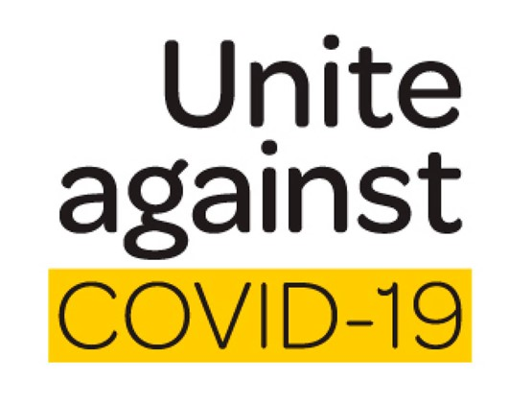
February 2022
Kia ora e te Whanau, I hope you all enjoyed your holiday break with your beautiful tamariki. The team at Western Heights Primary school are so excited to get the school year underway. Sadly, the news of the Omicron Variant has meant we have to plan for the possible spread of the virus within our Kura and School Community.
It is now time for Whanau to make their home Covid-19 plan.

The Government has made it very clear that the Omicron Variant is on our doorstep, and it won’t be long before we have cases in our community and in our Kura. The school has plans in place to keep our staff and students safe but, at some point, we are likely to have cases.

There are 3 possible scenarios that you need to plan for. The process to be followed for each scenario follows;

- A pupil or teacher in your child’s class tests positive for Covid-19
- The Director of Education, Ministry of Education will be informed.
- Whanau will be informed.
- Your child will be classified as a Close contact.
- Your child will have to self-isolate for the time stated by the Ministry of Health.
- Your child will be required to take a Covid-19 Test.
- After a Negative test result is received your child still must complete the self-isolation process before they can return to school.
- Siblings attending Western Heights Primary School and potentially other schools will also have to go through the same process.
- Parents, Nan’s, Koro’s living in the same home will also need to be tested.
- Inform the school as soon as test results are received as it will impact on how the school operates.

- A pupil or a teacher in your child’s class is a Close contact of a confirmed Covid-19 Case. This means the pupil, or the teacher was in direct contact with the Positive Covid-19 case.
- The Director of Education at the Ministry of Education will be informed.
- Whanau will be informed.
- The Close contact student or teacher will self-isolate and go through the Covid-19 testing process.
- Your child can continue to attend school if they are not the Close contact student.
- You may choose to keep your child at home until the Close contacts Covid-19 test result is made available. A remote learning program will be offered to your child if you choose to keep them at home.
- If the Close contact returns a Positive Covid 19 test, then your child will become a Close contact.
- That will mean your child will be required to take a Covid-19 test and self-isolate for the required period. The Close contact process is mentioned in scenario 1.
- Once your child receives a Negative Covid-19 test result they can return to school at the end of the isolation period.

- If the school has a Covid-19 outbreak, cases identified in several classrooms.
- The Director of Education at the Ministry of Education is informed.
- The Director of Education will liaise with the Ministry of Health and the School will likely be closed.
- All students would connect to the Digital Learning Program offered by their classroom teacher.
- The Director of Education would inform the school when we can reopen.
- School would not be open for any students. Planning for this now as a Whanau is imperative.

There are other potential scenarios but the 3 documented are the most likely.
- If your child is unwell, they need to stay home, get them tested.
- If your child is going to be away for more than 2 days, please inform your child’s teacher so they can provide an educational package.
- When your child is well, they need to be at school. Their learning will suffer if they are regularly absent.
- It is a concerning time and we understand that many of you are feeling anxious. Let’s work together to keep our tamariki safe.
Thank you
Brent Griffin

